Manual guide for Eventsplusapp

Table of Contents

Admin Guide 2

Login 2

Register 3

View data 5

View details 6

Insert data 7

Edit data 9

Delete data 11

User Guide 12

Login 12

Register 14

View data 15

# Admin Guide

## Login

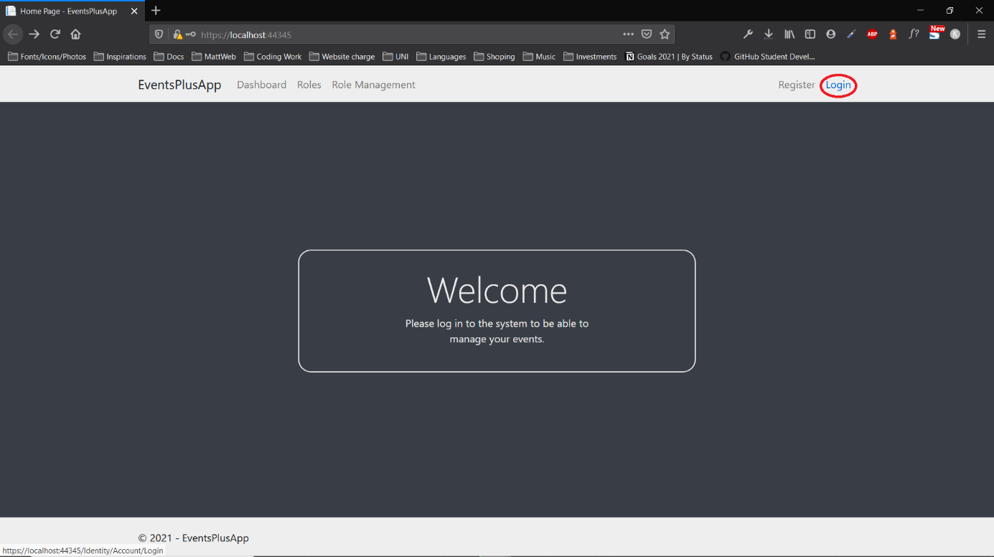

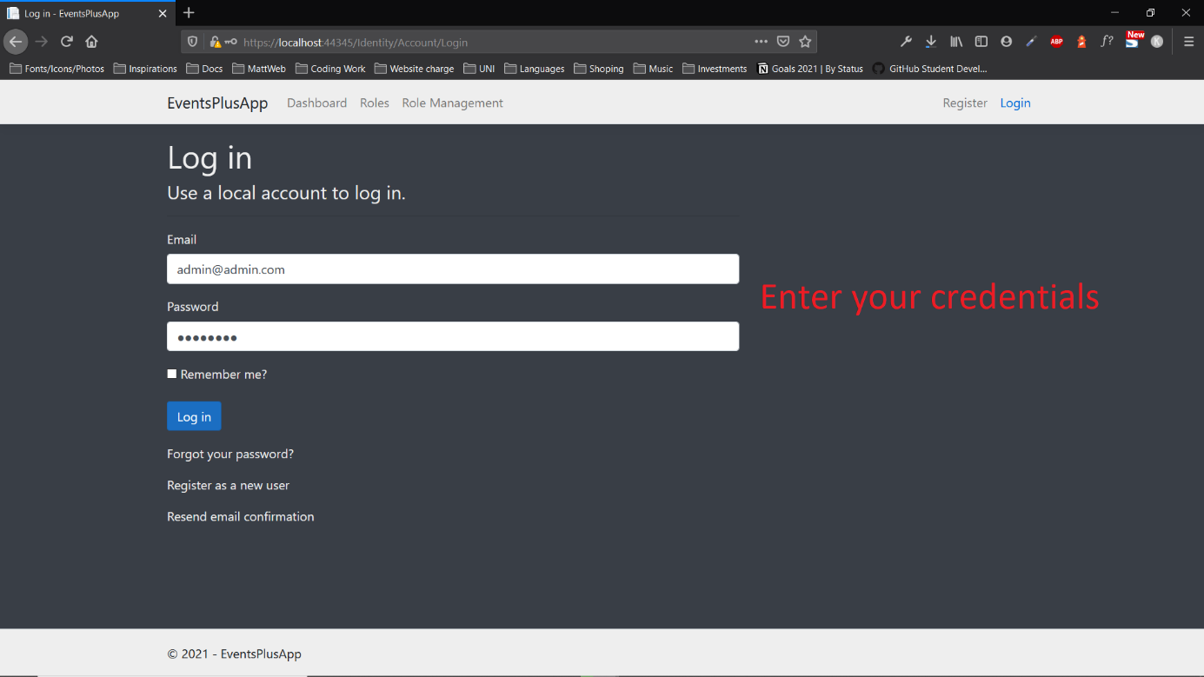

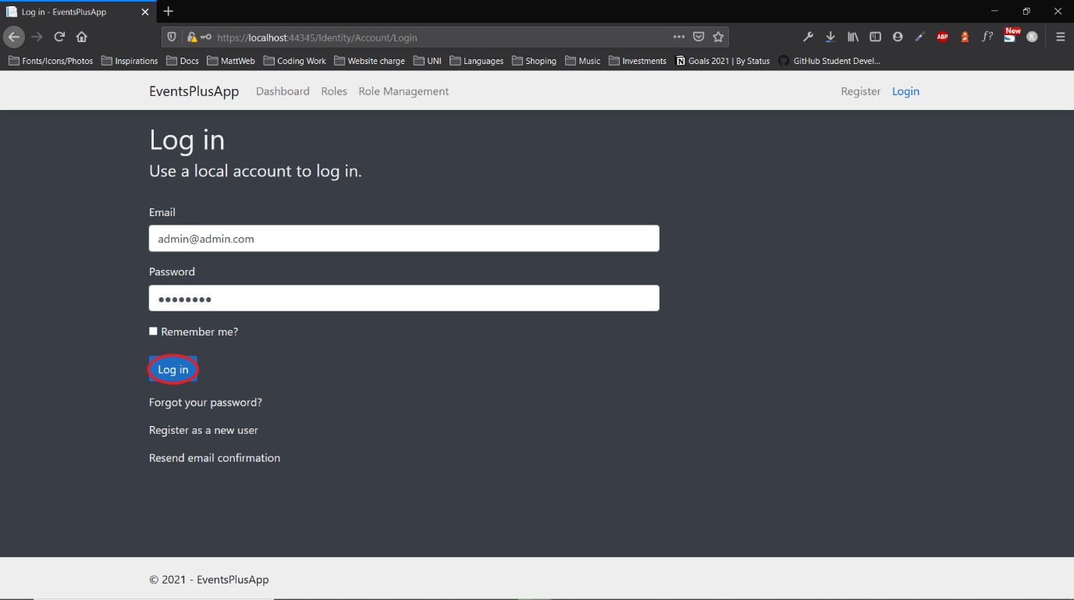

## Register

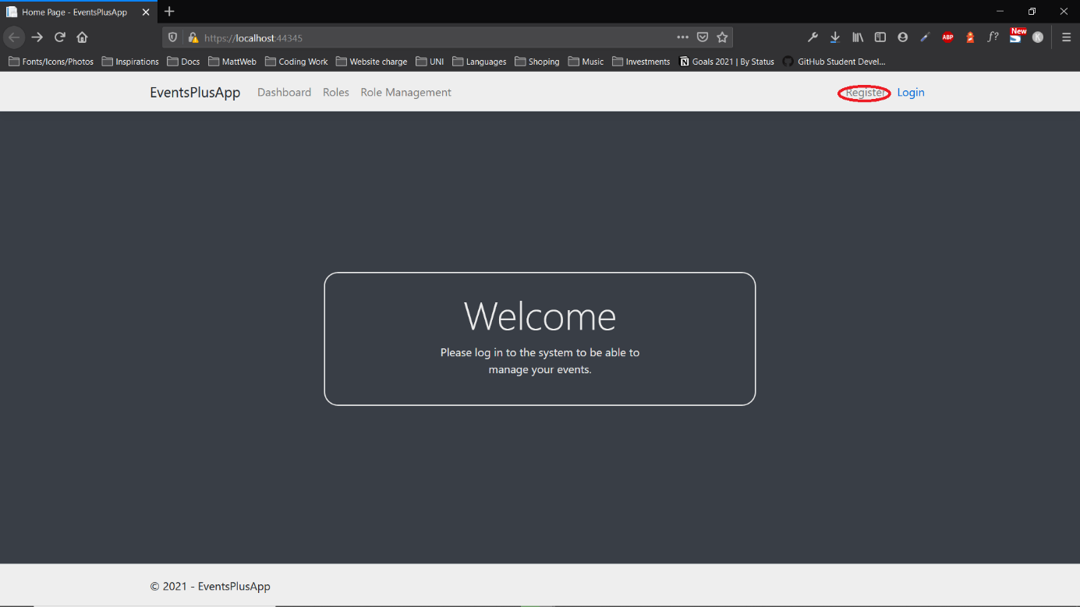

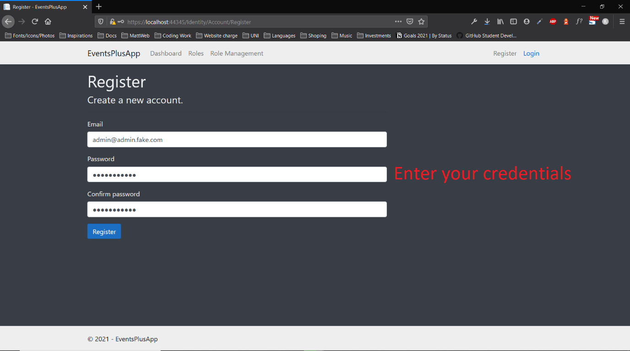

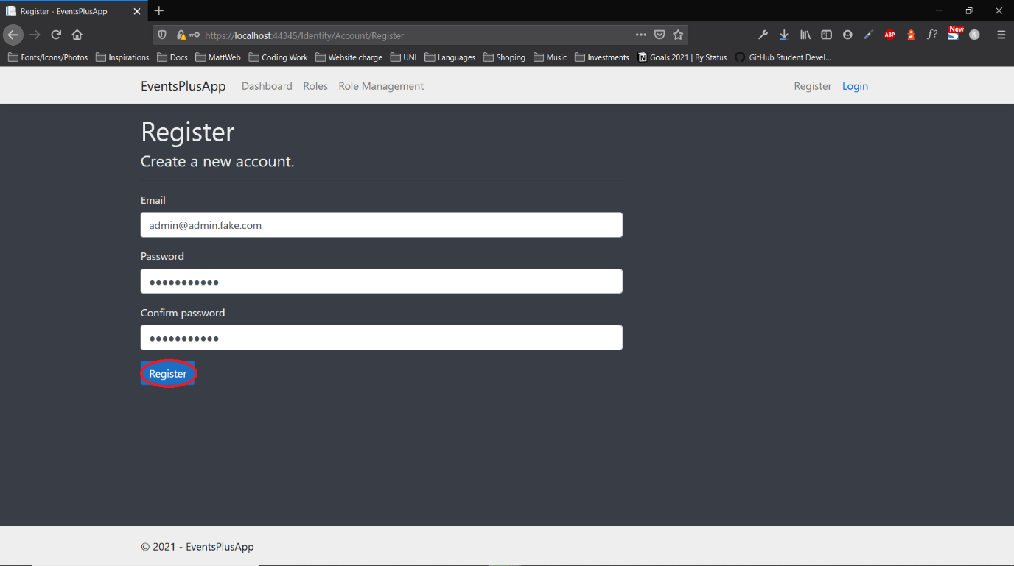

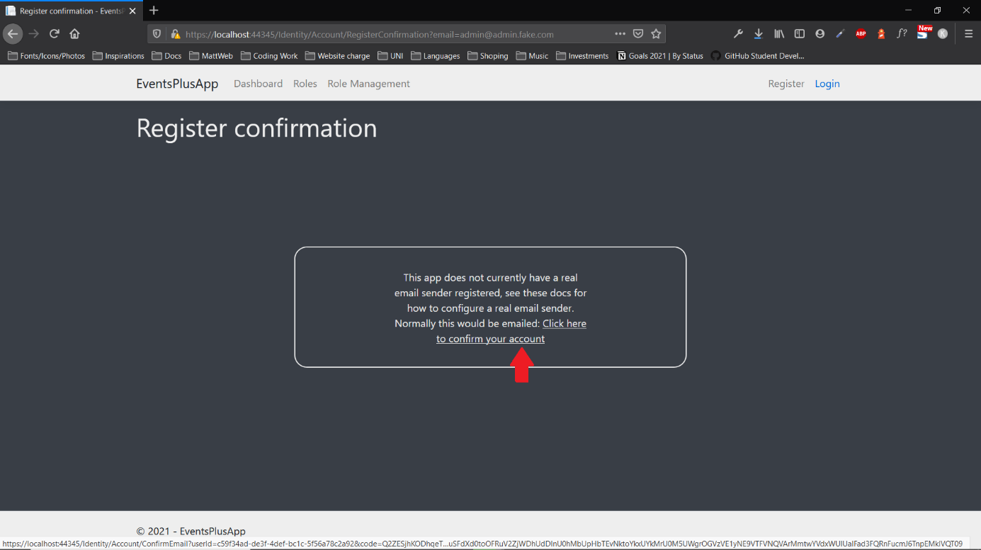

## View data

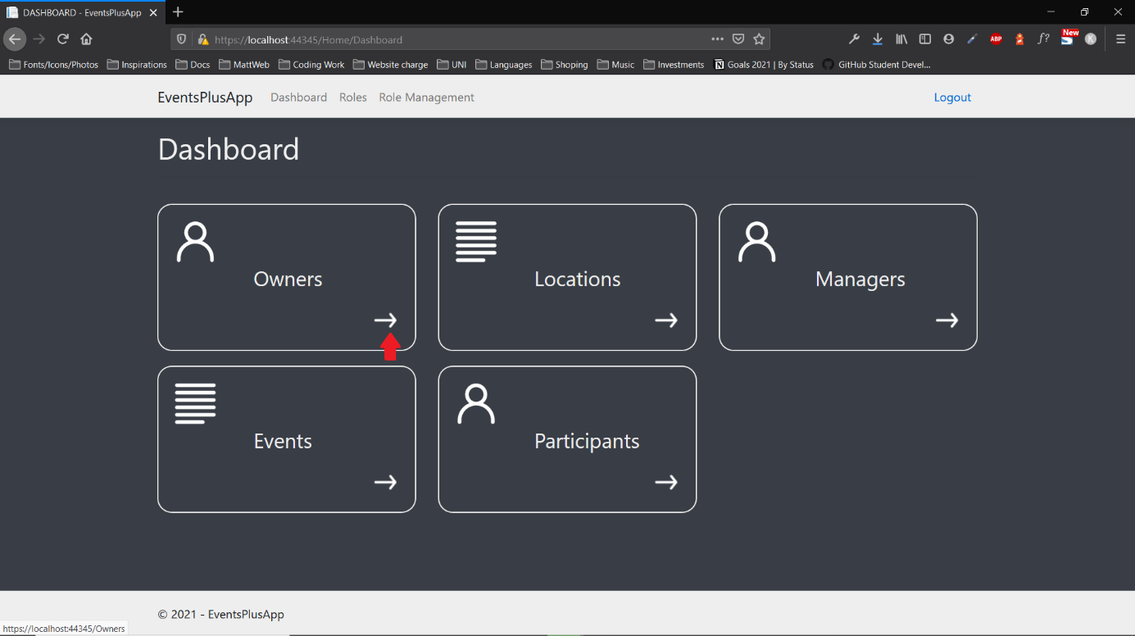

## View details



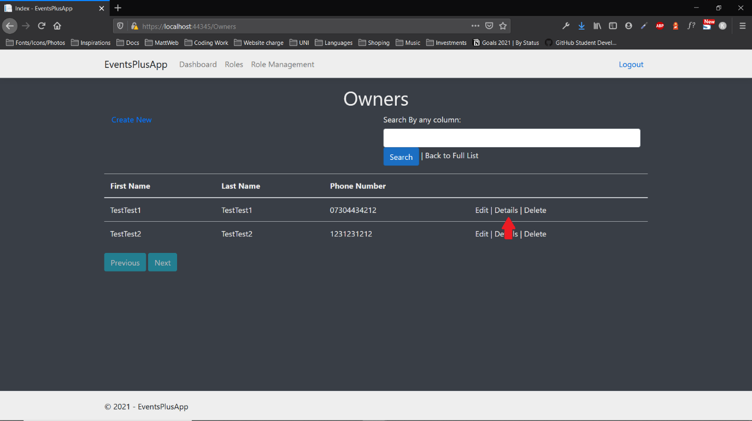

## Insert data



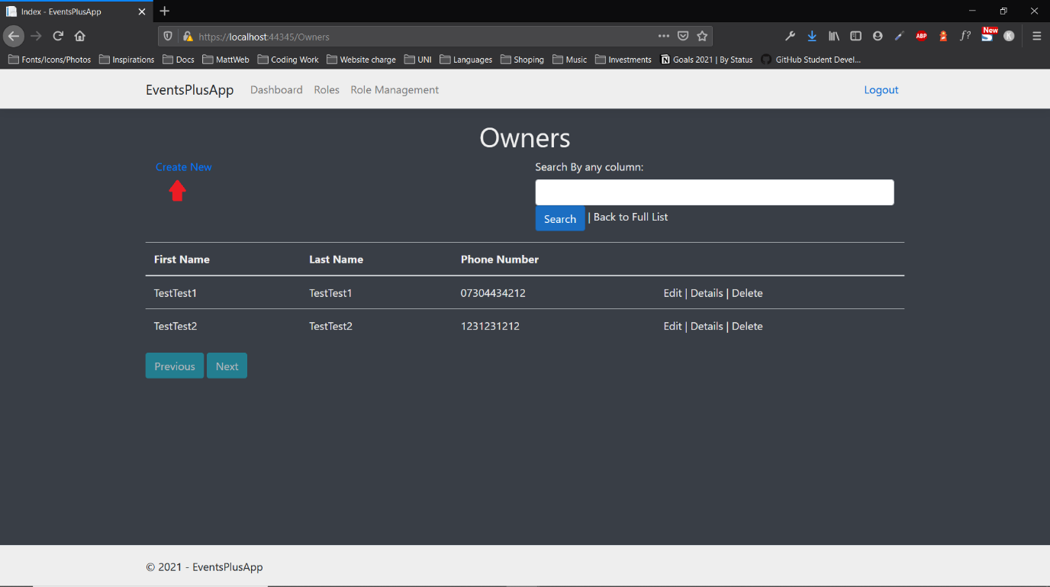

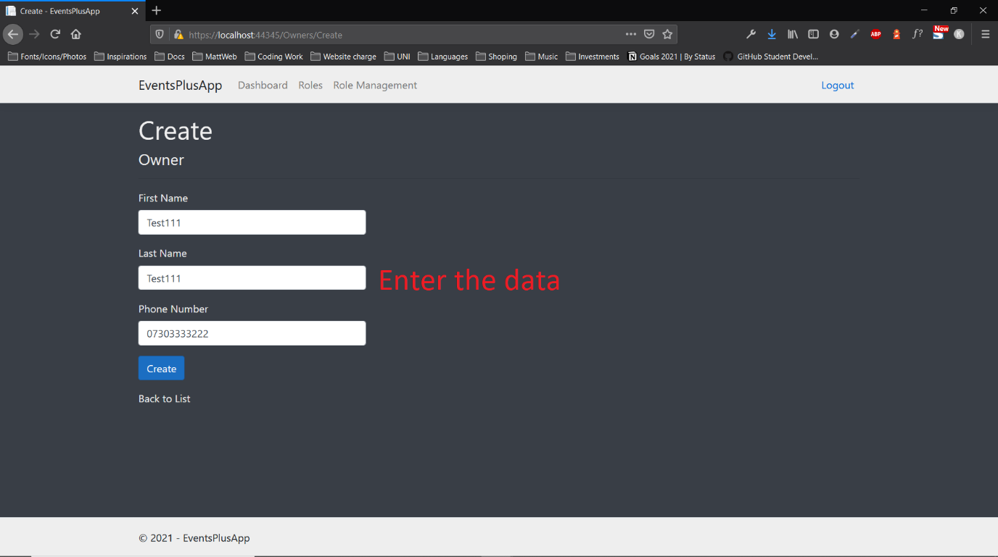

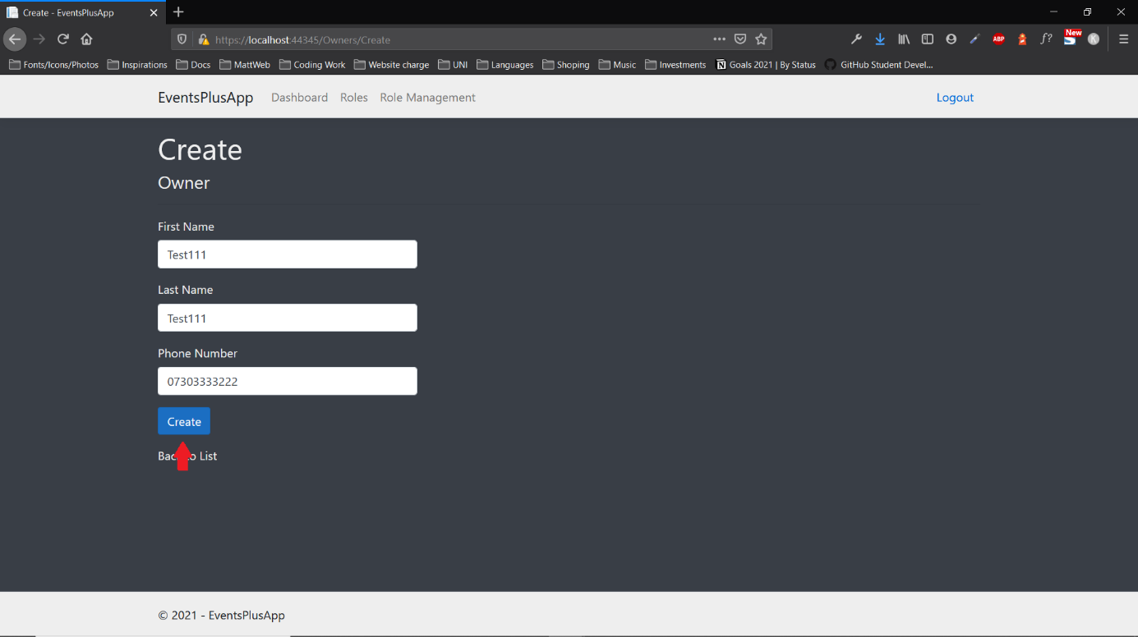

## Edit data



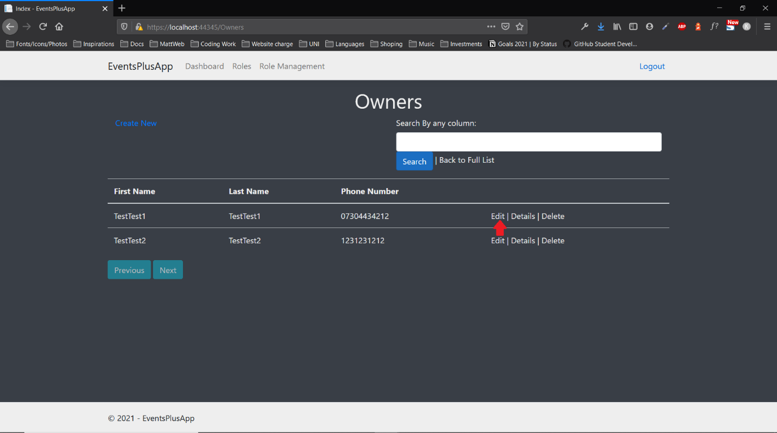

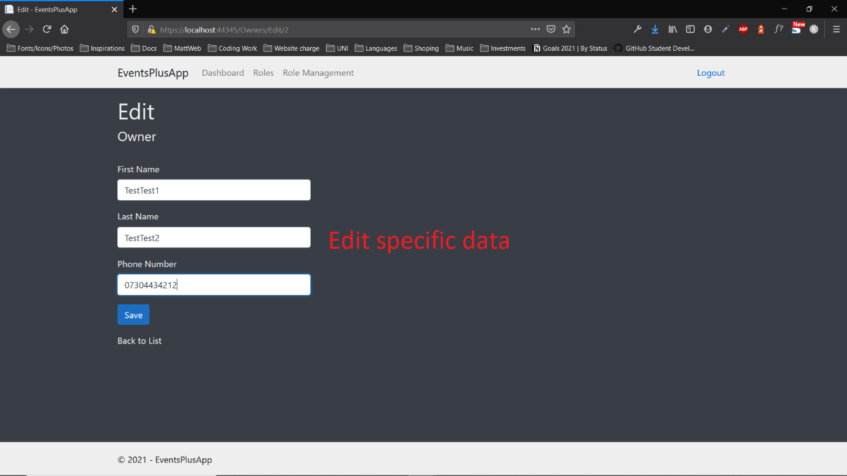

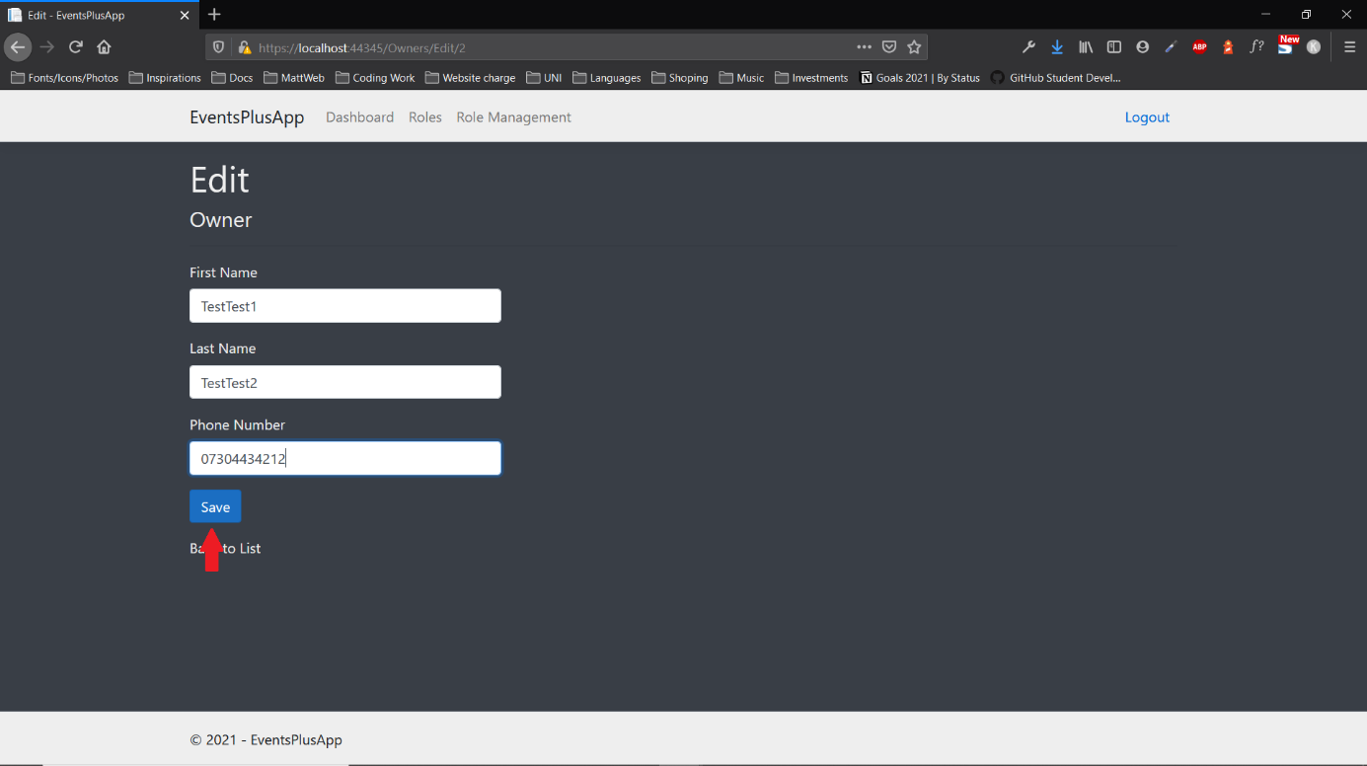

## Delete data



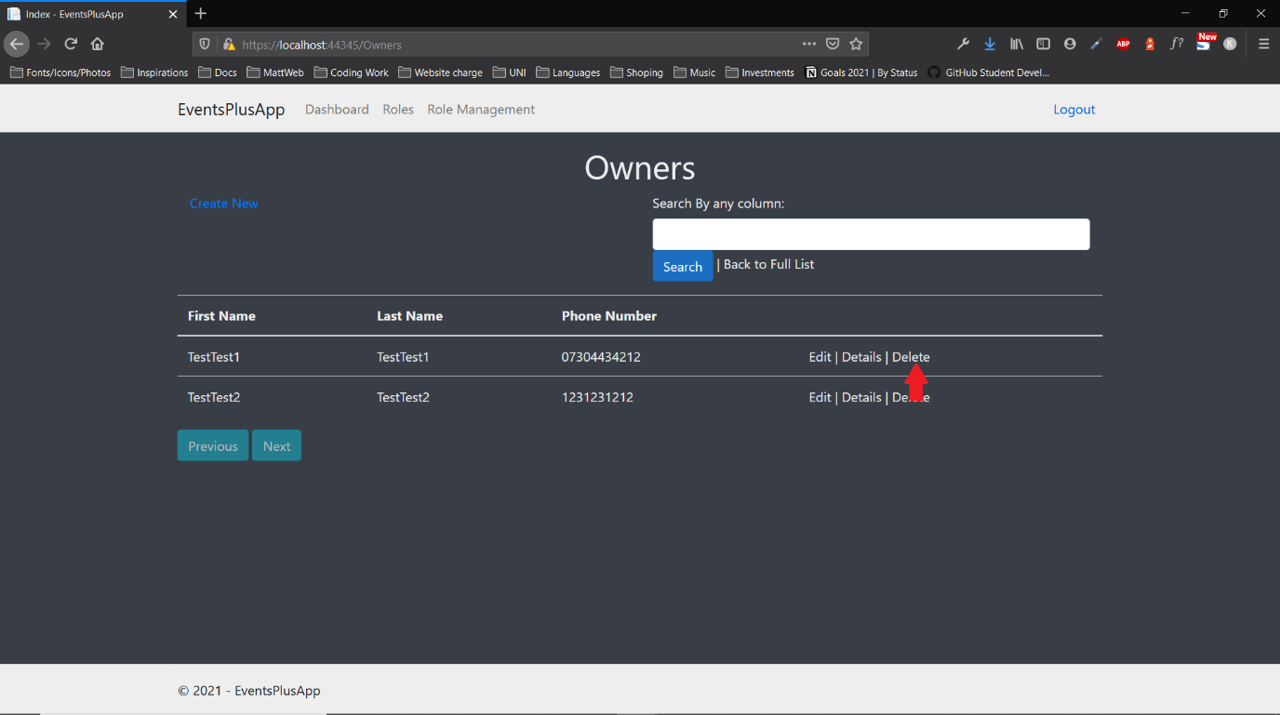

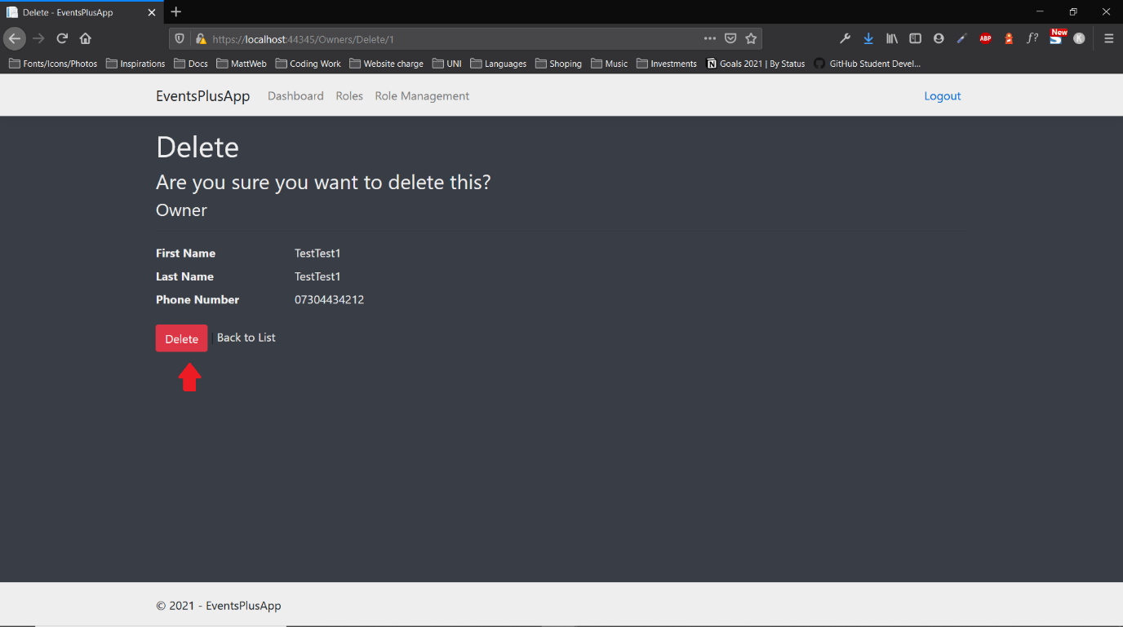

# User Guide

## Login



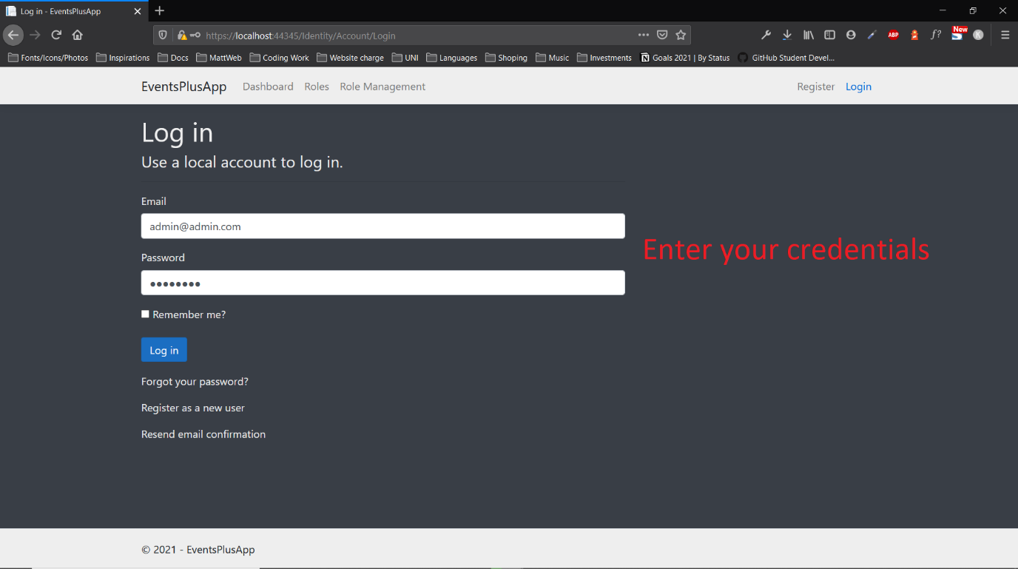

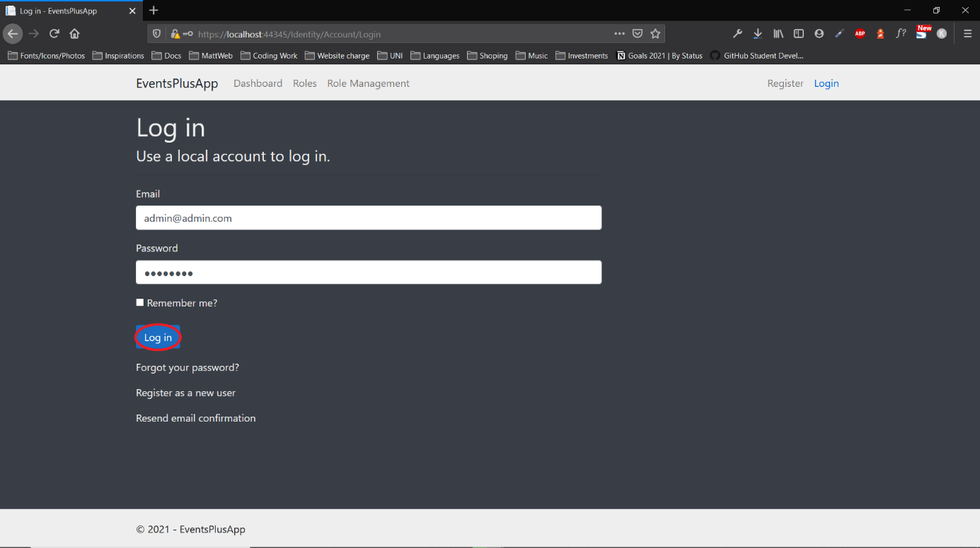

## Register







## View data

